Digital Fleet Audit

Introduction
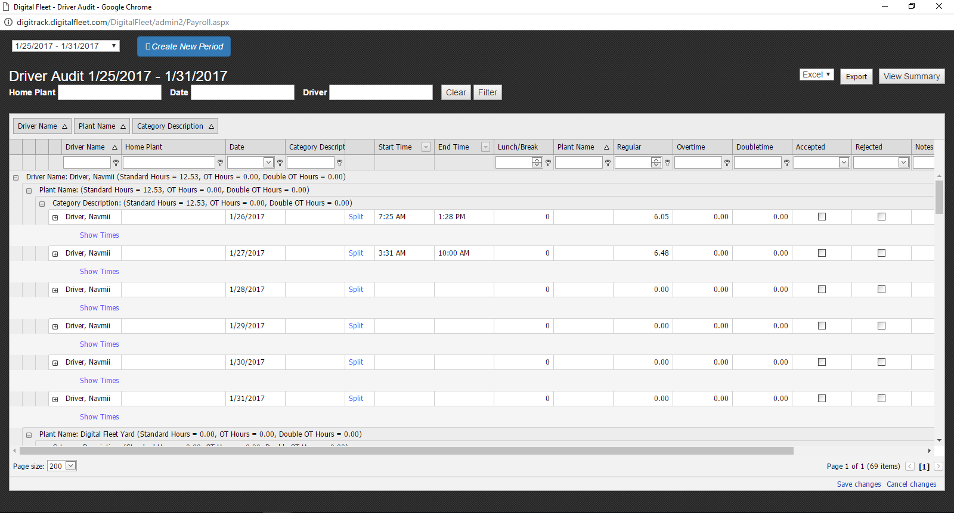
The Audit report is designed to help the Payroll Department determine a driver’s payable hours. The user can create a payroll period by clicking the blue “Create New Period” button and selecting the start/end dates for the period. This will display all the hours for each employee on each day between the selected dates. The 3 textboxes at the top can filter by Home Plant, Date, and Driver Last Name (Example below).
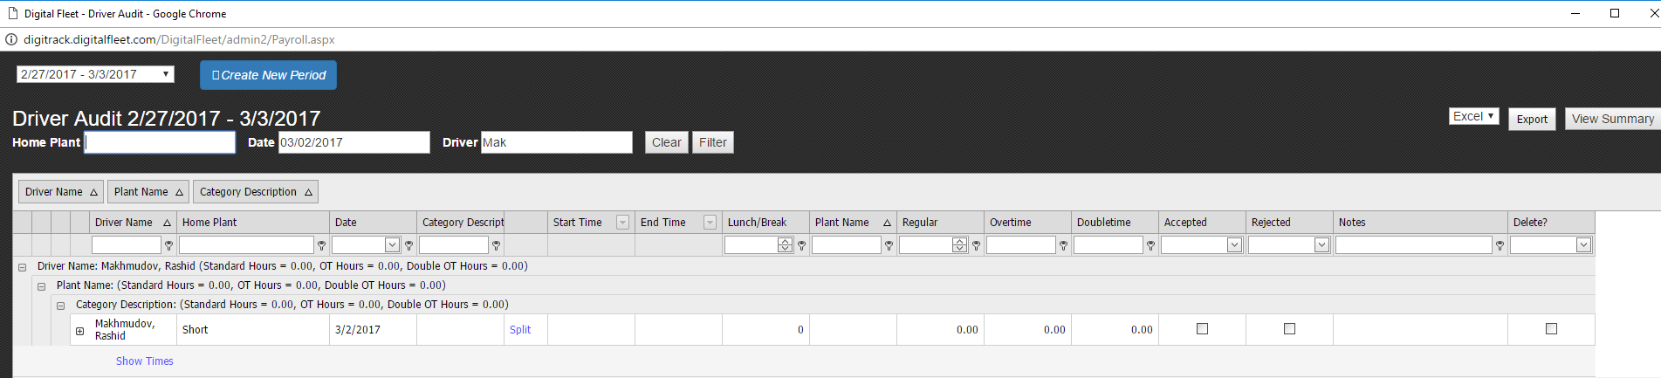

The next row of textboxes can also be used for filtering the data.
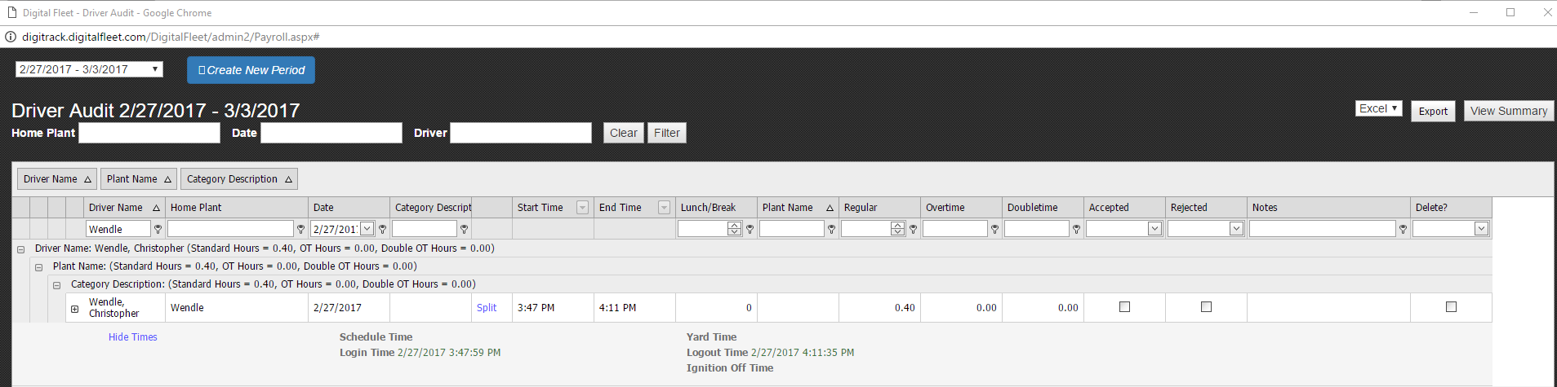
Clicking the plus (+) button next to the driver’s name will display all the tickets the driver received during that day. Below you can see that Chris Wendle received 2 tickets on 2/27/2017. It shows the Truck he was driving, the Plant he loaded out of, the Order number of the Job, Ticket number, Job City, Login Time, Start Time, and other important data. 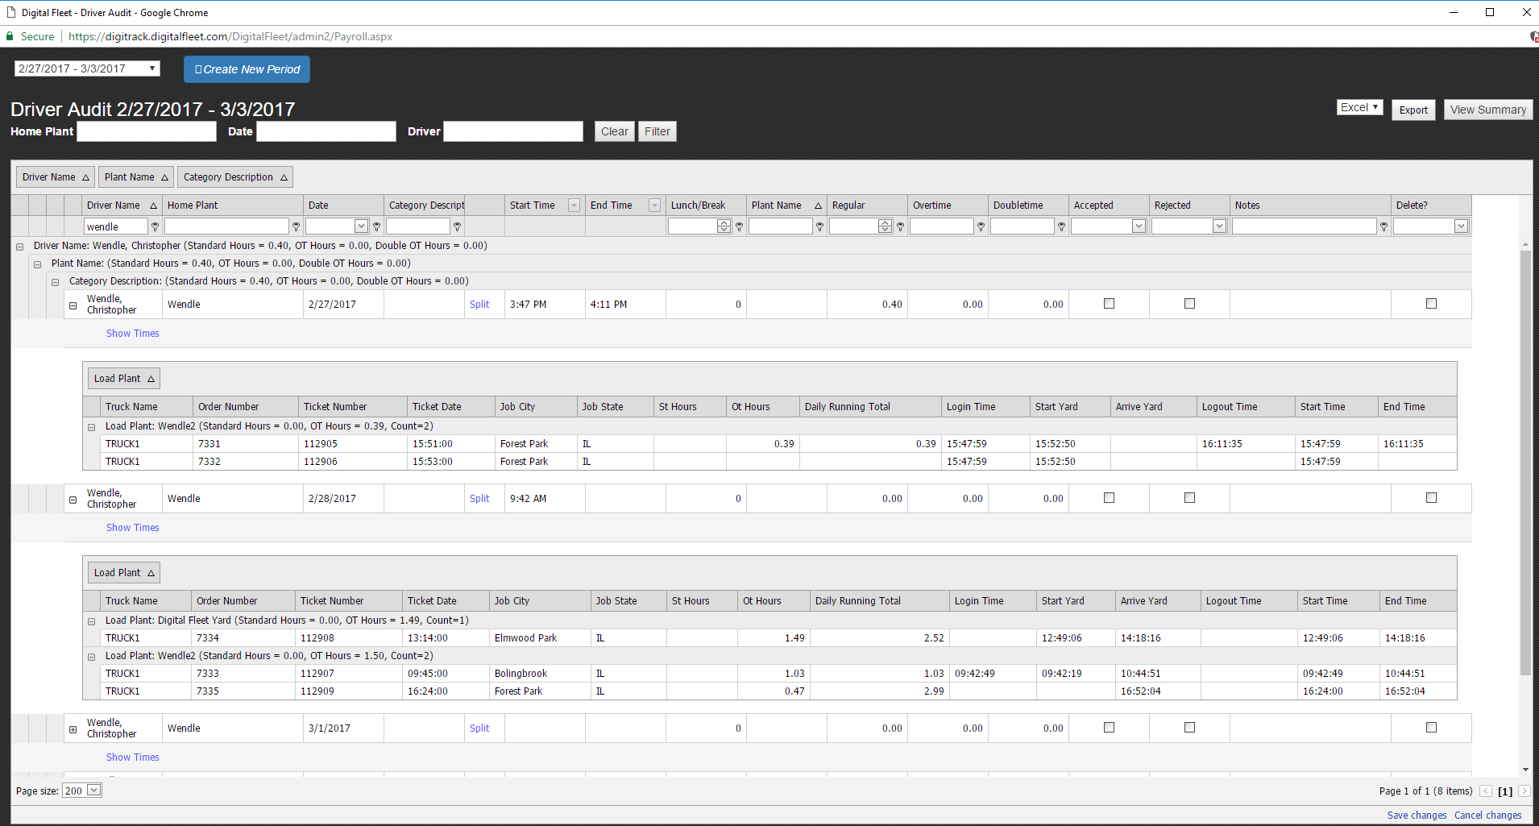
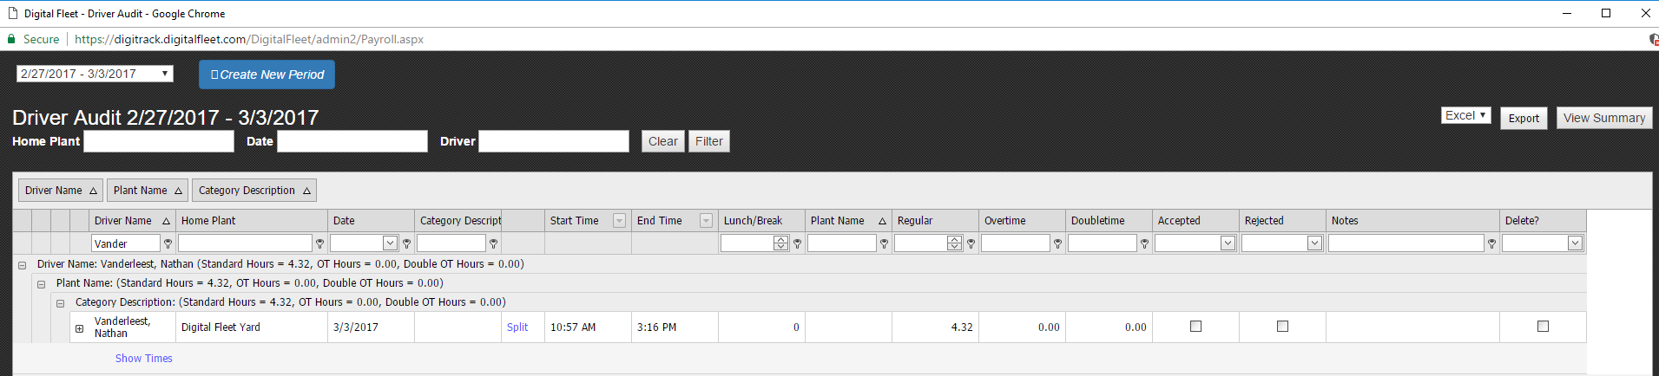
To begin with, there is only one payroll detail (record) for each driver on each day (shown above). By clicking the “Split” button, you can split a day into 2 payroll details (records). (Shown below)
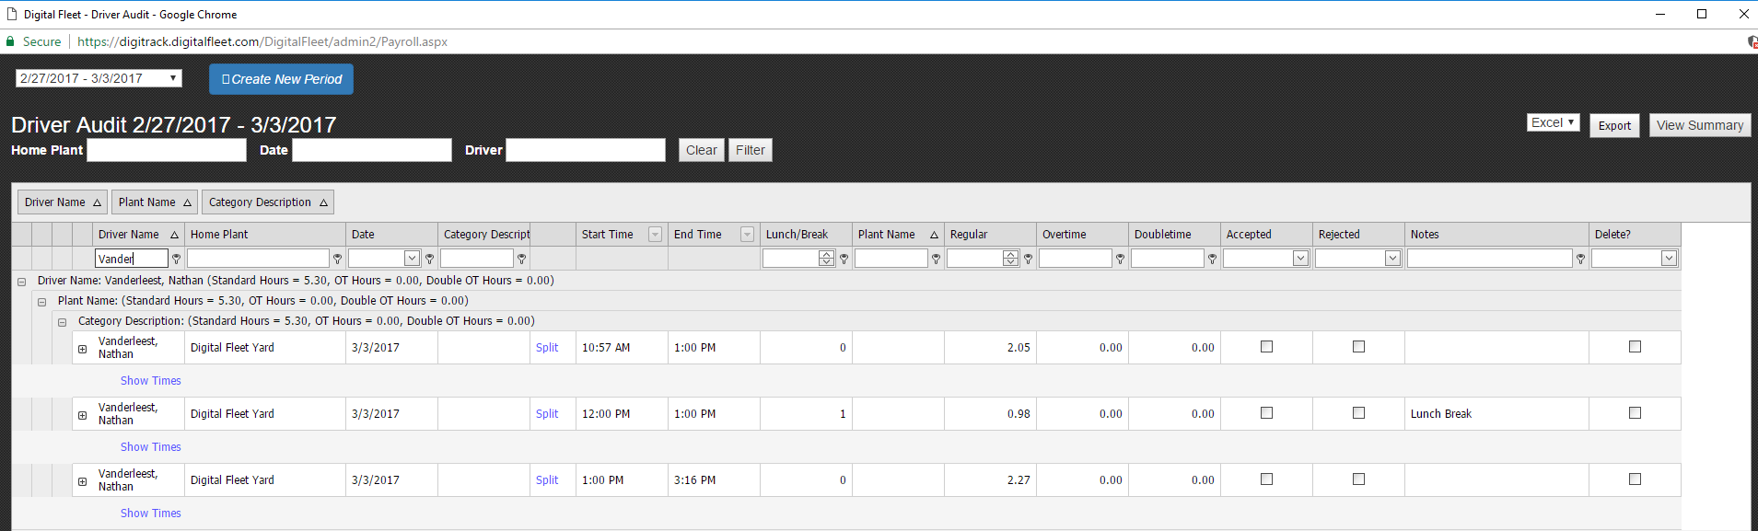
If there is a payroll detail (record) you want to get rid of, you can check the Delete checkbox in the right most column (Shown below). Then Click “Save Changes” in the bottom right corner.
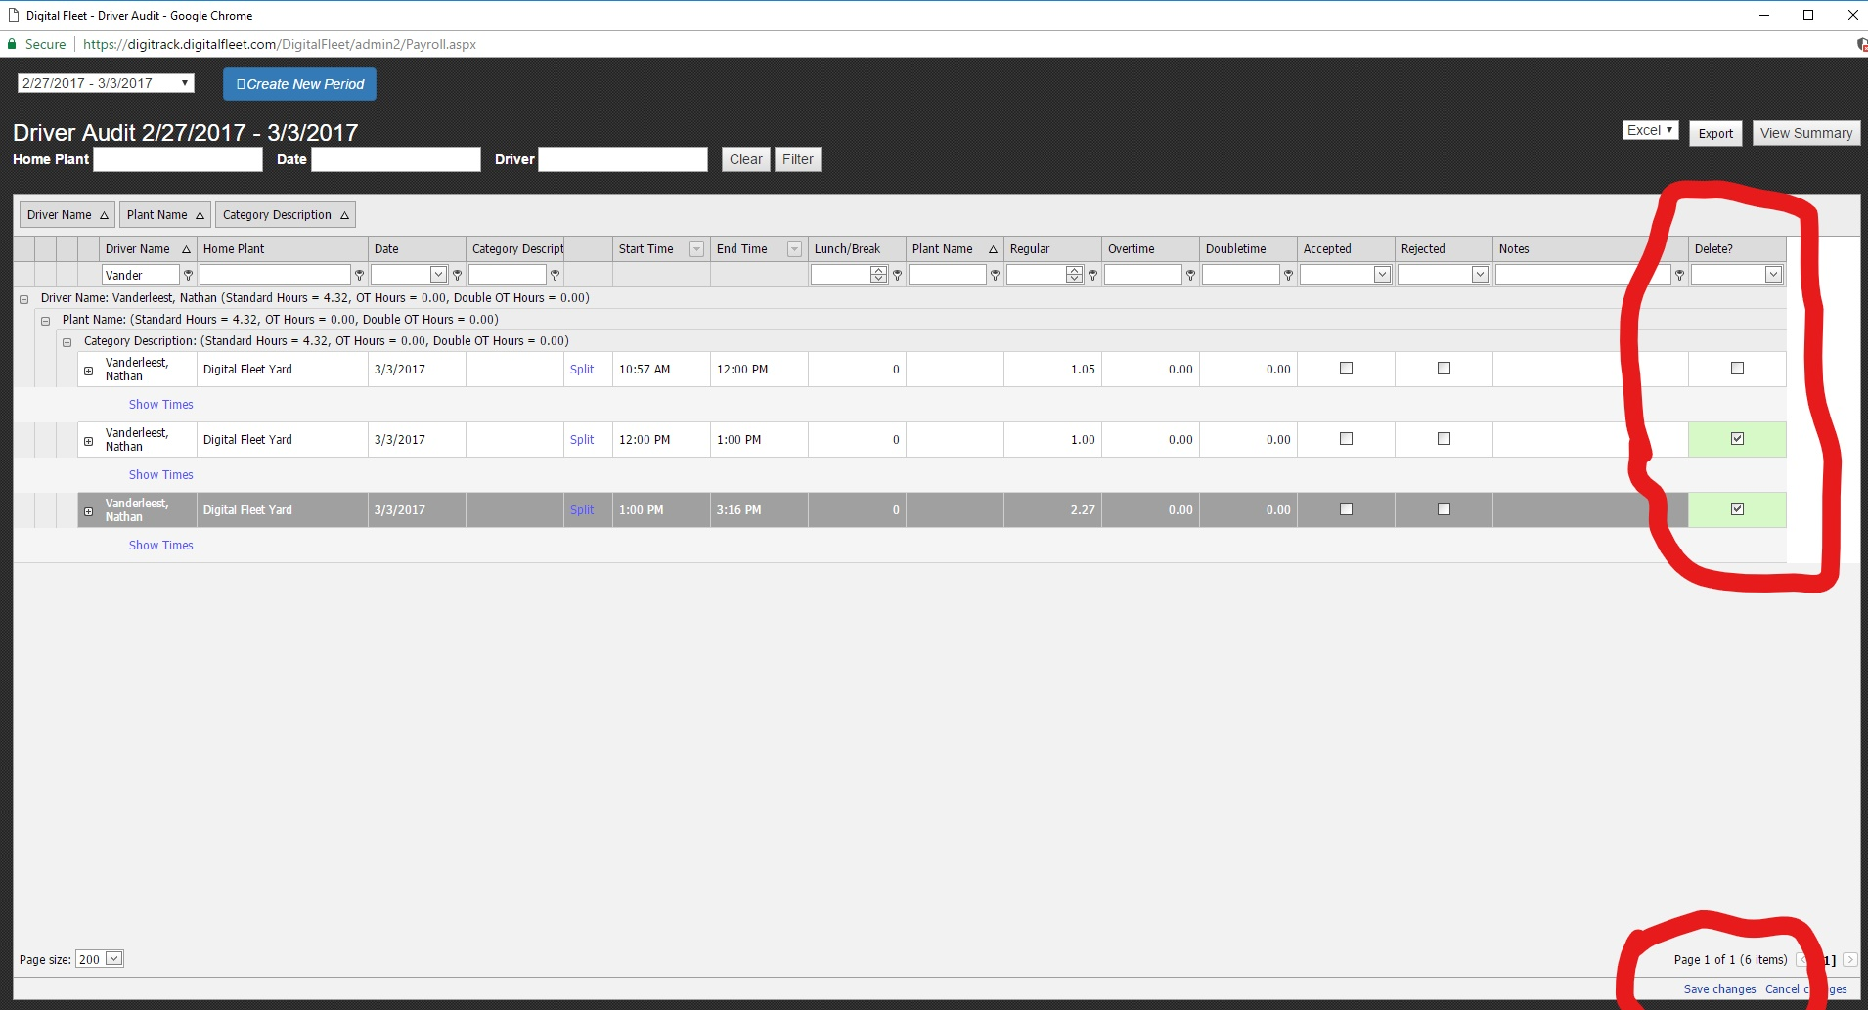
Additionally, the Start and End Times can be updated for manually updating driver times and the Notes section allows for adding information about the record to the report.

Then the data can be viewed by selecting the View Summary button.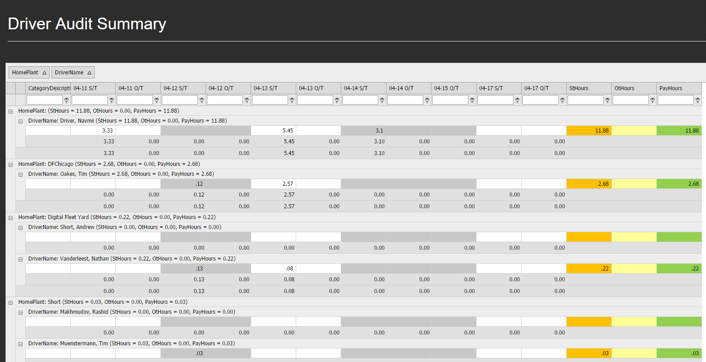Additionally the data can be exported with the Export button.
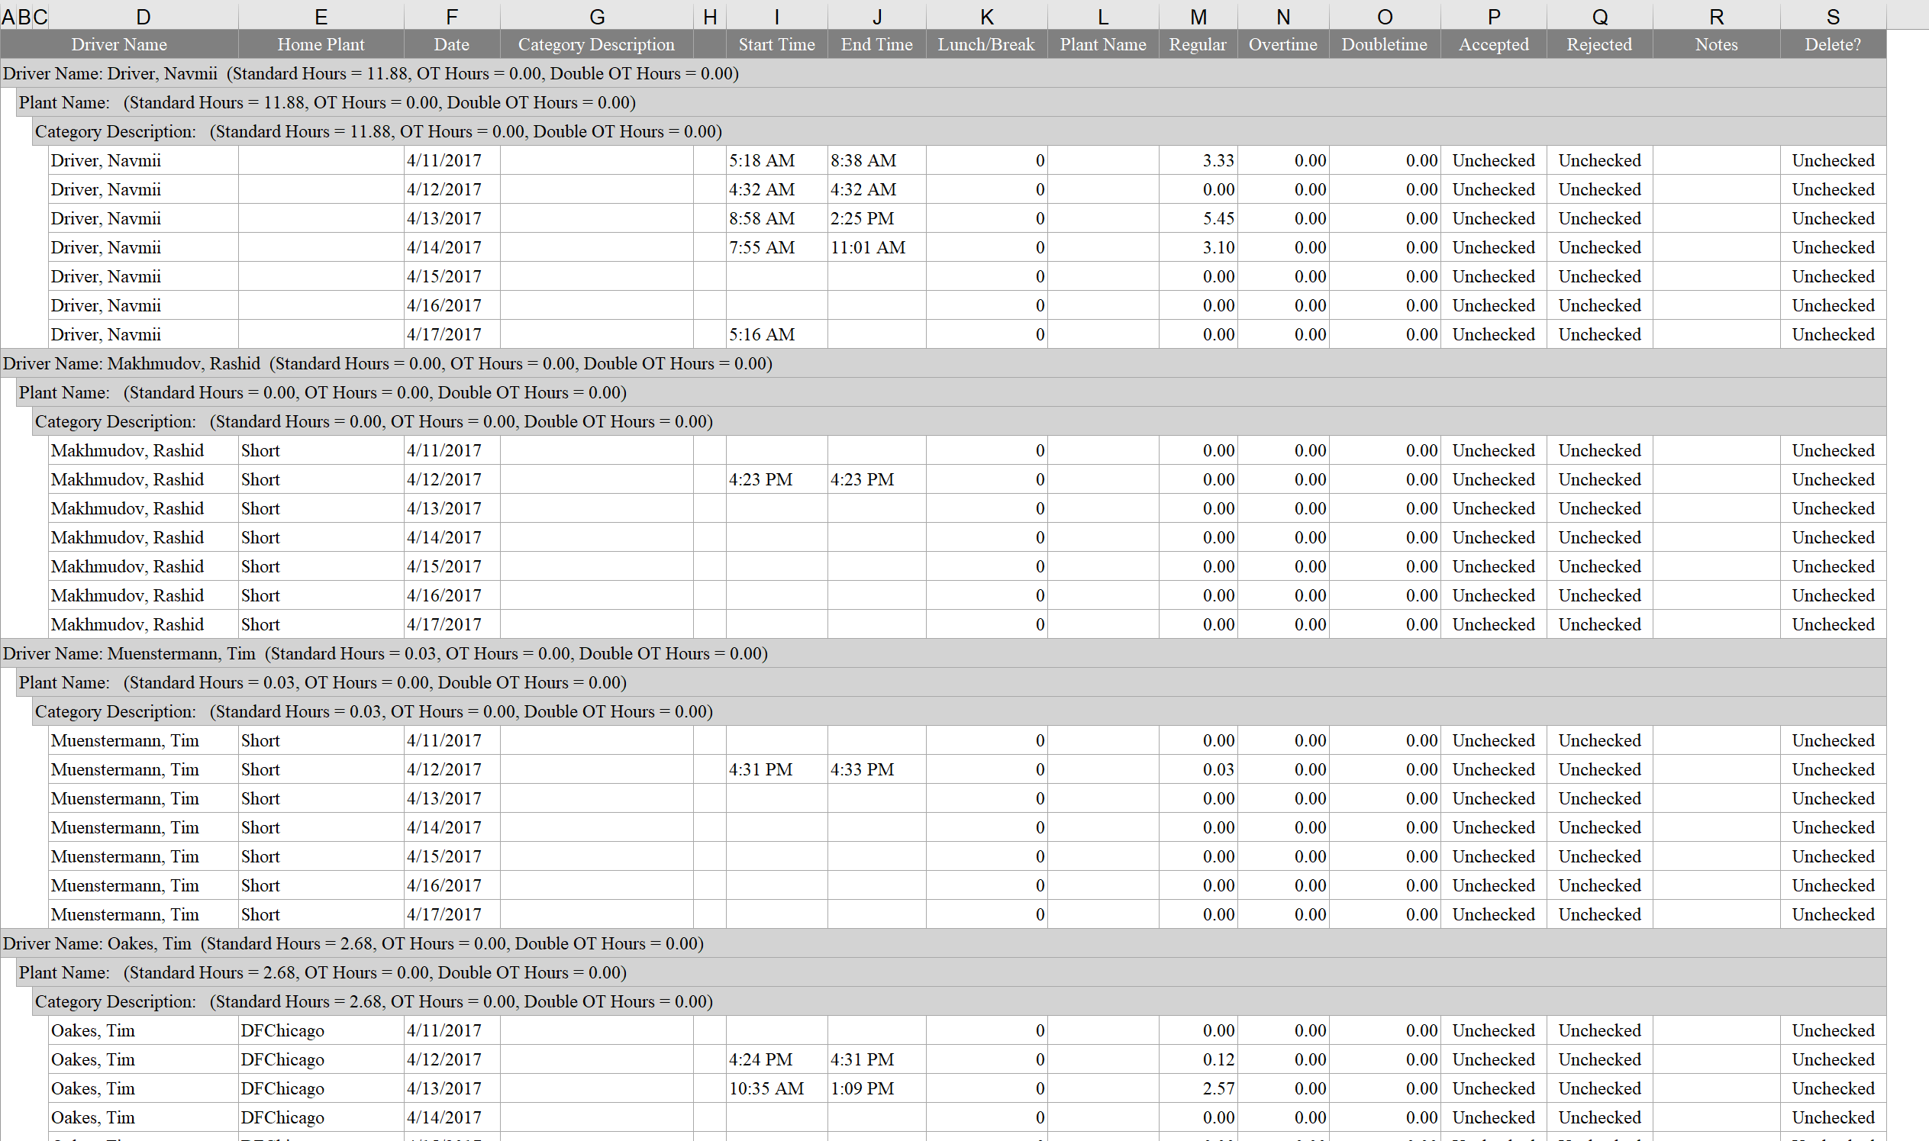

When the Driver Audit feature is enabled, it is displayed above the map for quick access to the information.
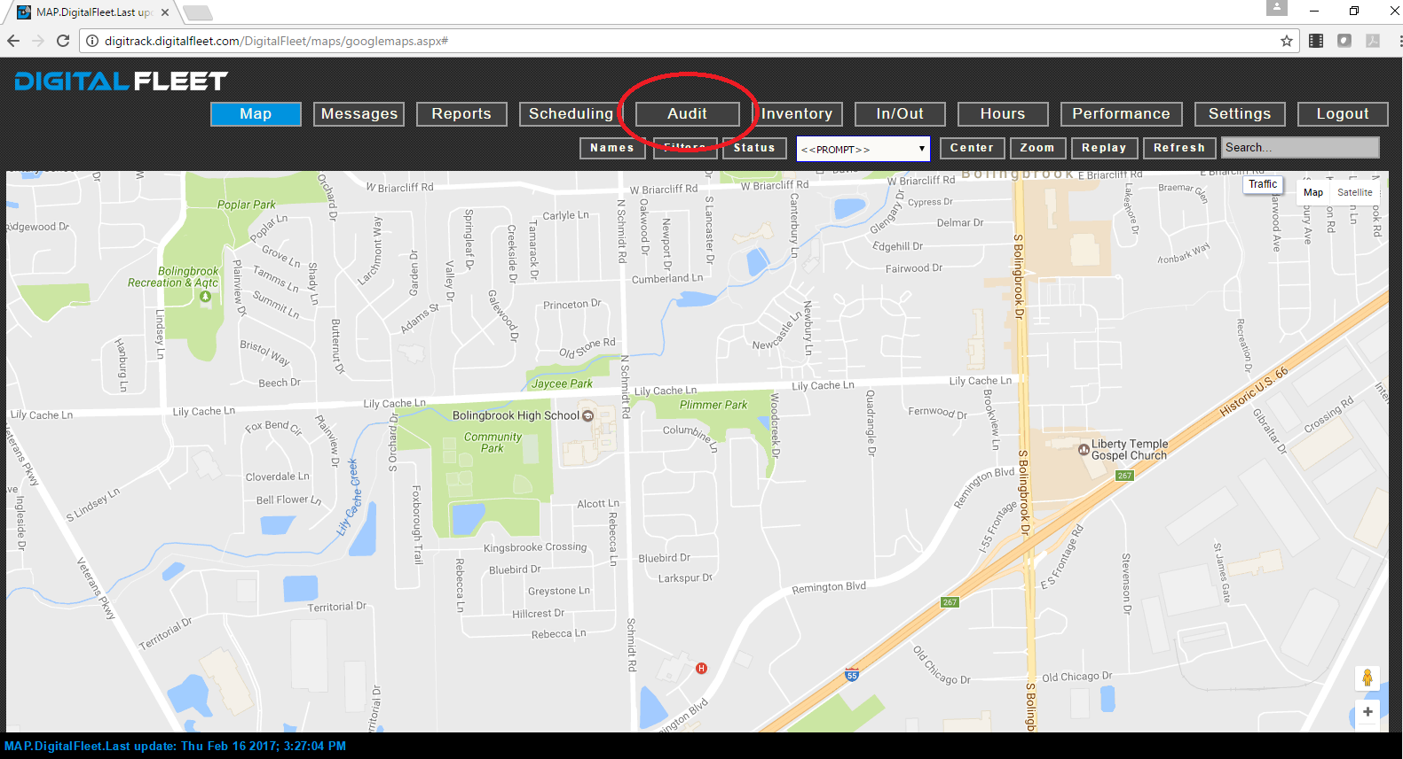
Here is what the Audit report looks like when it is first opened (Blank).
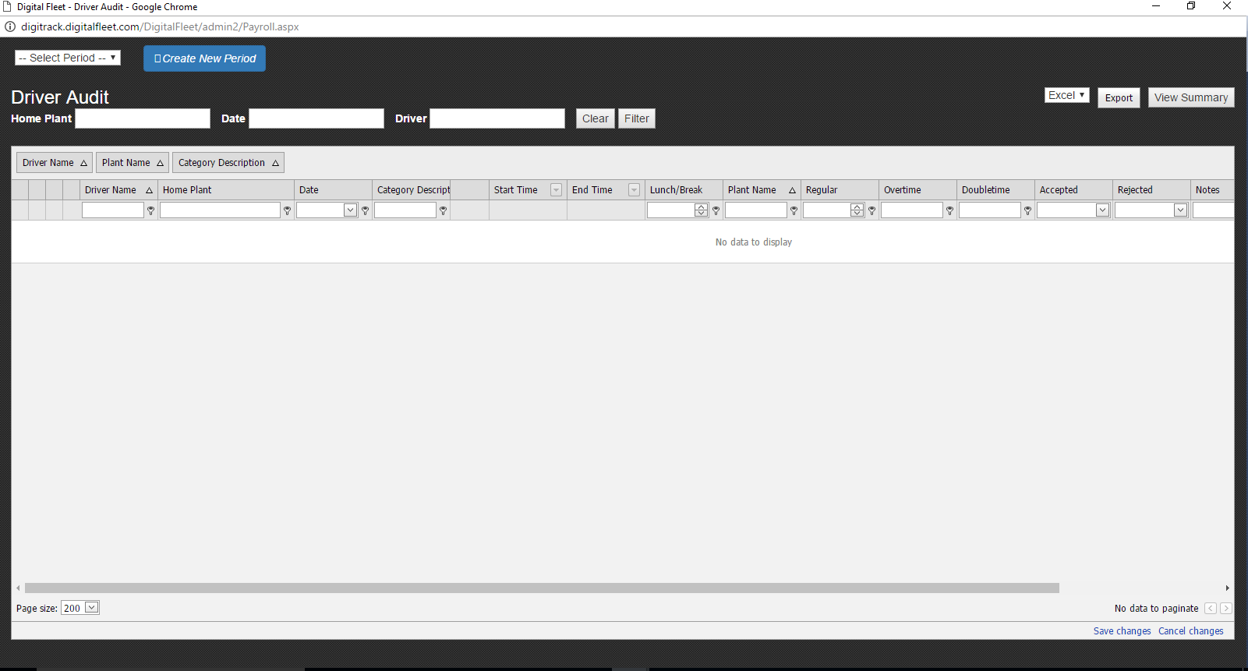
In the upper left hand corner, there is a “Select Period” Dropdown Box. The dropdown list shows all the periods that were created in the last 6 months.
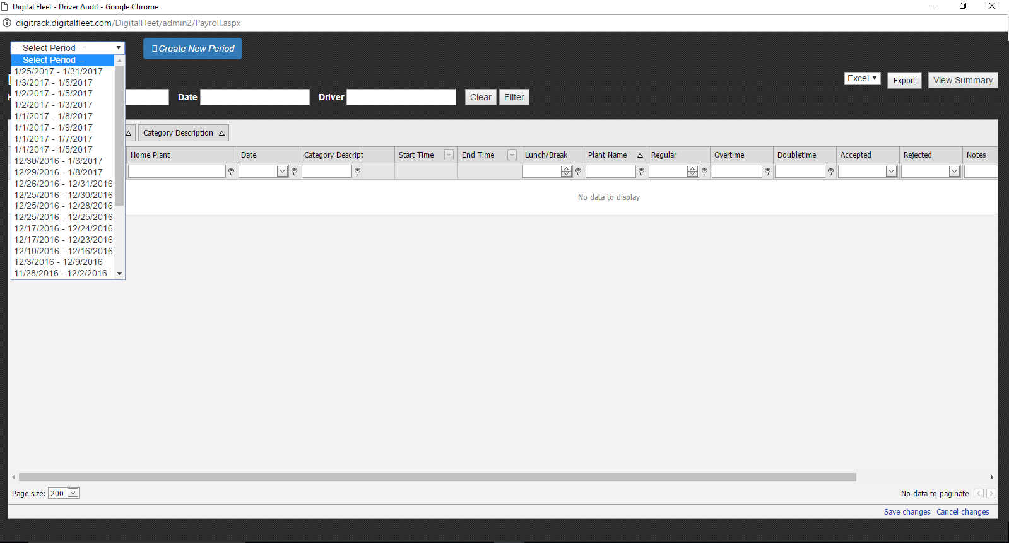

The hours for all the drivers during that time period are displayed. The data is grouped by driver, in alphetbetical order by last name. Below you can see the Navmii driver’s hours from the 25th to the 31th.

